1 Application
CQB9aL-63 residual current operated circuit breaker is applicable to the circuit with an alternating current of 50Hz or 60Hz, rated-voltage single pole and two lines 230V, three pole four lines 400V, and a rated current up to 63A; when the human body gets an electric shock or the network leak current exceeds the specified value, the residual current operated circuit breaker can rapidly cut off the power supply in trouble within a very short time for the safety of the human body and the powered equipment. With the function of overload and short circuit protection, the residual current operated circuit breaker can be used to protect the circuit or motor from being damaged by overload and short circuit, and can also be used for not-frequent operational transformation in the circuit under normal condition.
The product meets the standards of IEC 61009-1 and GB16917.1 .
2. Type designation
CQ B 9a L - 63
Rated current(A)
Function code (LE: electronic type RCBO)
Design serial number
Miniature circuit breaker
CHAC

3 Technical data
Model 1P+N 3P+N
Rated voltage(v) : | 230V~ | 230~/ 400~
Rated current(A) : | 6、10、16、20、25、32、40、50、63
Rated Leakage Operating ln (mA) | 10、30、100、300
Rated residual non-operating current : lno(mA) | 0.5ln
Poles : | 1P+N |  | 3P+N
Rated breaking capacity : lcu(A) | 6000
Rated residual making and breaking capacity l m | 6000
Maximum breaking time of the residual current operating | Table 2
Tripping characteristic : | Table 3
Mechanical life & Electrical life: | Mechanical life：10000 ； Electrical life: 4000
Nominal cross section area S (mm2) : | Table 4
Pollution degree: | 2
Protection class: | IP20
Overvoltage category : | Ⅱ、Ⅲ

Table 2 Maximum breaking time of the residual current operating

Type | ln (A) | ln (mA) | Breaking time when the residual current assumes the following values (s)
 |  |  | ln | 2ln | 5ln
General type | Any value | Any value | 0.1 | 0.05 | 0.04

Table 3 Over current protection characteristic

Rated current(A) : Test current Initial situation Tripping time Test result Remarks
6~63 | 1.13In | Cold state | t≥1h | Not-trippin
6~63 | 1.45In | Right after test a | t＜1h | trippin | Current stablely raised to specified value in 5s
6~63 | 2.55In | Cold state | 1s＜t＜60s(In≤32A)  1s＜t＜120s(In＞32A) | trippin | C
6~63 | 5In | Cold state | t≥0.1s | Not-trippin | C
 | 10In |  | t＜0.1s | trippin

Table 4 Nominal cross-sectional area of the copper conductor

Rated current （A） Nominal cross-sectional area of the copper conductor （mm²）
6~16 | 2
20~32 | 2.5
40~63 | 4

4 working and the installing condition.
4.1 : Ambient max temperature is no more than +40℃, minimum temperature is not less than -5℃. No more than +35℃ within 24 hours;
4.2 : altitude is no more than 2000m;
4.3 : when the highest temperature reaches 40℃ the air relative humidity of the installing place can't exceed 50%, when in the low temperature it will have the relative higher humidity. When the average largest relative humidity in the most humiddest it is month no more than 90%, then the monthly-average
temperature is no more than 25℃. We must take measure of the dew in the surface of the product due to the
temperature;
4.4 Installation conditions
Any direction of the outer magnetic field of the installation site should not exceed 5 times than earth's magnetic field; residual current operated circuit breaker should be mounted vertically, all places inclination no more than 5 °,power position above the handle , the installation place should be no significant impact and vibration
5. Overall and mounting dimensions (mm)
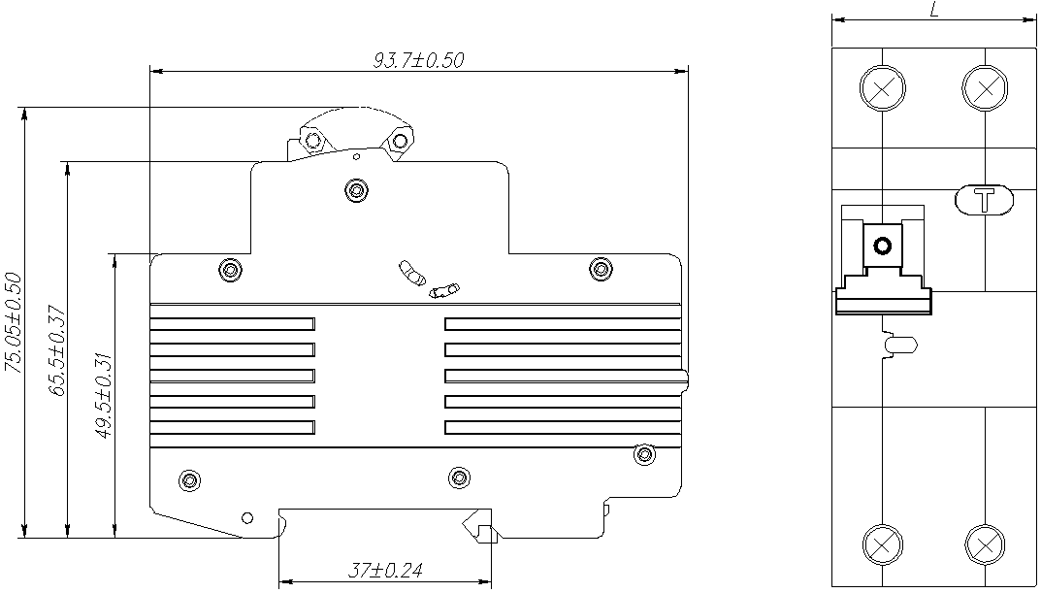

Poles : L(mm)
1P+N | 35.6±0.10
3P+N | 71.2±0.20

