1 Application
MXa overvoltage and undervoltage tripping device is mainly used for AC 50Hz, rated voltage 230V line and CQB5a series circuit breaker equipment made under voltage protection.
Standard Number：GB14048.5、IEC60947-5-1。
2 Technical data
Model Versions
Rated thermal current （Ue） | AC230V 50Hz
Rated insulation voltage (Ui) | 415V
Operation property | 175V~255V，
 | 265V±10V
 | 165V±10V
life | 4000
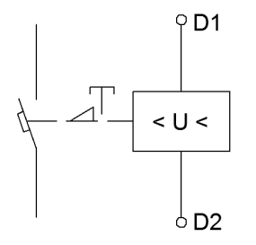
3 working and the installing condition.
3.1 Ambient temperature：-25℃~+50℃
3.2 relative humidity：≤90%/20℃，≤50%/40℃
3.3 altitude is no more than 2000m
diagram

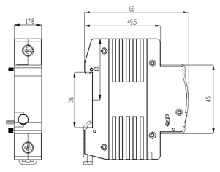
4. Overall and mounting dimensions (mm)

