1 Application
MX shunt tripping device is mainly used for AC 50Hz, rated voltage 230V line and CQB5a series circuit breaker equipped with long distance shunt tripping operation.
Standard Number：GB14048.5、IEC60947-5-1。
2 Technical data
Model Versions
Rated voltage of control power supply Us | AC 230V 50Hz
Rated insulation voltage (Ui) | 415V
Operation property | （70%~110%）Us，the release reliably operates to break the circuit breaker
Life(operations) | 4000
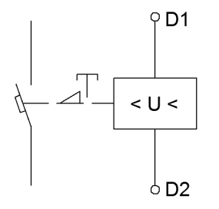
3 working and the installing condition.
3.1 Ambient temperature：-25℃~+50℃
3.2 relative humidity：≤90%/20℃，≤50%/40℃
3.3 altitude is no more than 2000m

diagram

4 Overall and mounting dimensions (mm)

